

**NYSE Market Data and Risk Analysis**

**CAPSTONE PROJECT - MGSC 5125-12**

**Professor- Dr. Enayat Rajabi**

Group-13



[This Photo](https://www.onyxtruth.com/2020/05/21/why-the-hood-doesnt-do-stocks/) by Unknown Author is licensed under [CC BY-NC-ND](https://creativecommons.org/licenses/by-nc-nd/3.0/)

**Group Member Details:**

|  |  |
| --- | --- |
| **Group Members** | **Student ID** |
| Anuj Tomar |  |
| Jasleen Kour | 0254437 |
| Rohit Soni |  |

**TABLE OF CONTENTS**

|  |  |  |
| --- | --- | --- |
| **Sr. No.** | **Topic Name** | **Page Number** |
| 1 | Introduction | 3 |
| 2 | Scope of Project | 3 |
| 3 | Problem Statement | 3 |
| 5 | Methodology | 4 |
| 6 | Dataset and Metadata | 4 |
| 5 | Data Preparation and Data cleaning | 5 |
| 6 | Time Series Analysis   * Price Analysis * Volume Analysis | 6 |
| 7 | Comparative Analysis   * Price Correlation Matrix * Normalization * Daily and Annualized Returns | 7 |
| 8 | Risk Analysis   * Annualized Risk * Sharpe Ratio | 11 |
| 9 | Portfolio Creation | 12 |
| 10 | Conclusion | 13 |

**INTRODUCTION:**

New York Stock Exchange is the one of the largest stock exchanges and one of the busiest and most important stock exchange with around 1.46 billion shares a day and with over 2800 companies which range from blue chip to high -growth companies. It is the world’s largest stock exchange in terms of market capitalization. The project is based on the data collected from the NYSE market data to analyze the performance of selected stocks as per different categories.

**SCOPE OF PROJECT:**

The goal of the project is to analyze the stock performance of the selected 25 stocks over the five-year period from Oct 2017 to Sep 2022. The stock performances have been evaluated by using the key parameters like Closing prices, Adjusted Closing prices and Volume traded per stock.

The project focusses on exploratory data analysis of stock prices, trading volumes and relative performance with the S&P 500 Index. Some of the main objectives of the project are:

* Identifying the trends in the market data specific to the category.
* Performing the basic Exploratory analysis.
* Identifying the risk involved in each stock to make profitable portfolio for customers.

The main goal of the project is to design the portfolio for the investors based on the choice of strategy and bearable risk.

**PROBLEM STATEMENT:** For course of our project, we designed some questions to better understand the data collected and conduct some exploratory research to create a portfolio for investors based on their strategy. Some of the key questions created are as follows:

* Analyzing the stock performances by visualizing the price and traded volume variation.
* Calculating the Daily returns and Annualized returns for each stock and to determine the total returns per each category.
* Calculating the Risk involved with investment of each stock.
* Creating a portfolio based on top performing stocks in terms of returns

**METHDOLOGY;** In our project we worked on Jupyter notebook for our data cleaning, data preparation as well as the data visualization and analysis. Our methodology included following steps:

1. Data collection: Data was collected from yahoo finance
2. Data preparation: Multiple stocks data were categorized and merged into one single file
3. Data cleaning: Merged data file was cleaned
4. Basic data analysis and visualization: selected variables were visualized
5. Calculations for Returns and Risk returns and risks were calculated to create a suitable portfolio
6. Portfolio creation and returns: Annualized returns were calculated and visualized for created portfolio

**DATASET AND THE METADATA:**

The data was collected in the form of the 25 CSV files downloaded from the yahoo finance across selected five categories of Finance, Healthcare, Consumer staples, Information Technology and Energy and 1 Excel file. For balancing the dataset, top five stocks with largest market size were selected across each category. The dataset only incorporates the equity stocks and one reference file of the market index for S&P 500 over the same period.

|  |  |  |  |  |  |
| --- | --- | --- | --- | --- | --- |
| SECTOR | IT | Healthcare | Financial | Consumer Staples | Energy |
| 1 | TSM (Taiwan Semiconductors) | JNJ (Johnson & Johnson) | JPM (JP Morgan) | UL (Unilever Ltd.) | XOM (Exxon Mobil) |
| 2 | BABA(Alibaba) | UNH (United Health) | BRK (Berkshire Pathway) | WMT(Walmart) | SHEL (Royal Dutch Shell) |
| 3 | ORCL (Oracle Corporation) | PFE (Pfizer) | V(Visa) | PG (Procter & Gamble) | TTE (Total Energies) |
| 4 | SAP (SAP SE) | LLY (Eli Lilly and Company) | MA (Mastercard) | KO (Coca Cola) | COP (ConocoPhillips Company) |
| 5 | CRM(Salesforce.com) | ABT (Abbott Corporation) | BAC (Bank of America) | PM (Philip Morris) | CVX(Chevron) |

The Final data file contains 1258 rows and 157 columns with major columns as Open, Close, High, Low , Adjusted Close and Volume. Although we have only focussed on Close and Volume Columns for our analysis.

**DATA PREPARATION AND DATA CLEANING:**

For the initial analysis the data collected in the CSV files was checked for any null values or missing data. Mostly the data was clean and no missing values were found as the data was downloaded from the financial website which organized and arranged the data in a format which was appropriate for analysis. The format of Date was aligned similar across all the files to avoid any errors.

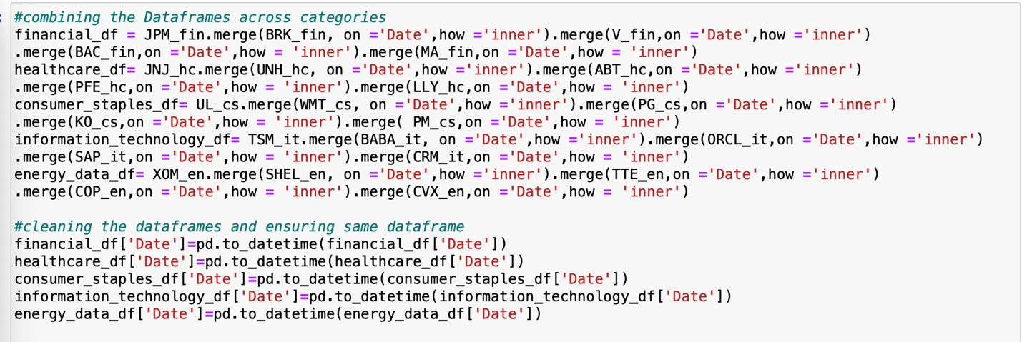

*Figure 1: Cleaning Data Files*

After data cleaning step, the data merging procedure was followed to create one single data file for analysis. Firstly, the individual stock files were merged into one market category data frame followed by all category data frames being merged into one single data frame. The final merged data frame also included the S&P 500 Index data file.

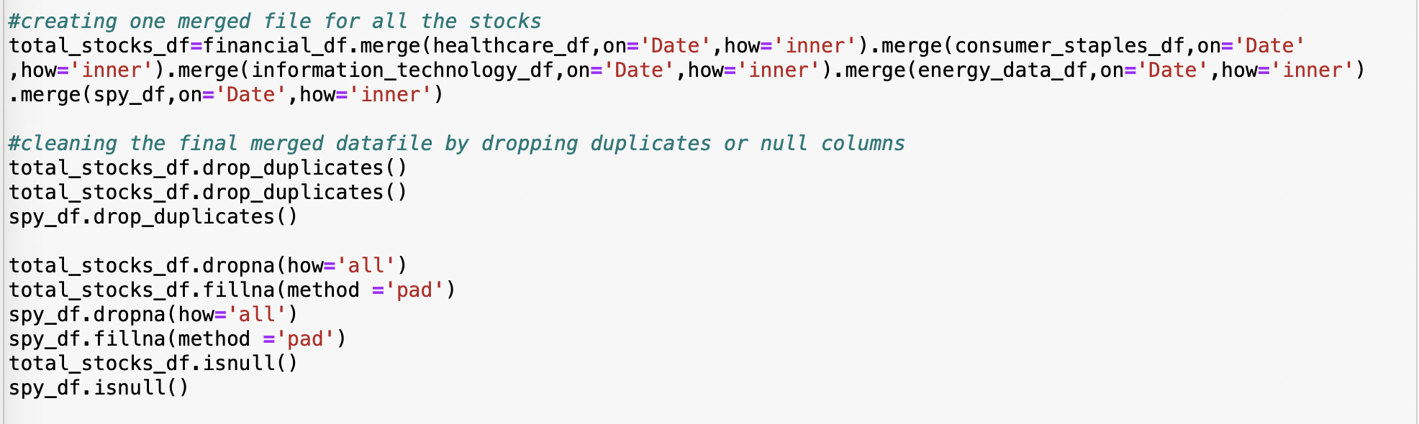

*Figure 2: Merging into Single Data Frame*

**TIME SERIES ANALYSIS:**

1. **Price Analysis:** The first and foremost analysis for any stock analysis is time series analysis for price and volume which depicts the performance of a stock in terms of fluctuation in closing prices over time and variation in terms of Quantity of the stock traded. The stocks whose prices have increased over the time could be less risky as compared to the ones with a downward trend in their prices. In our initial analysis across the categories, the energy stocks recorded the downward trend while most of the health category stocks recorded the upward trend. So for investment opportunity we should consider the stocks which have positive increase in their prices over time.



*Figure 3: Creating Closing Price Line Graph*

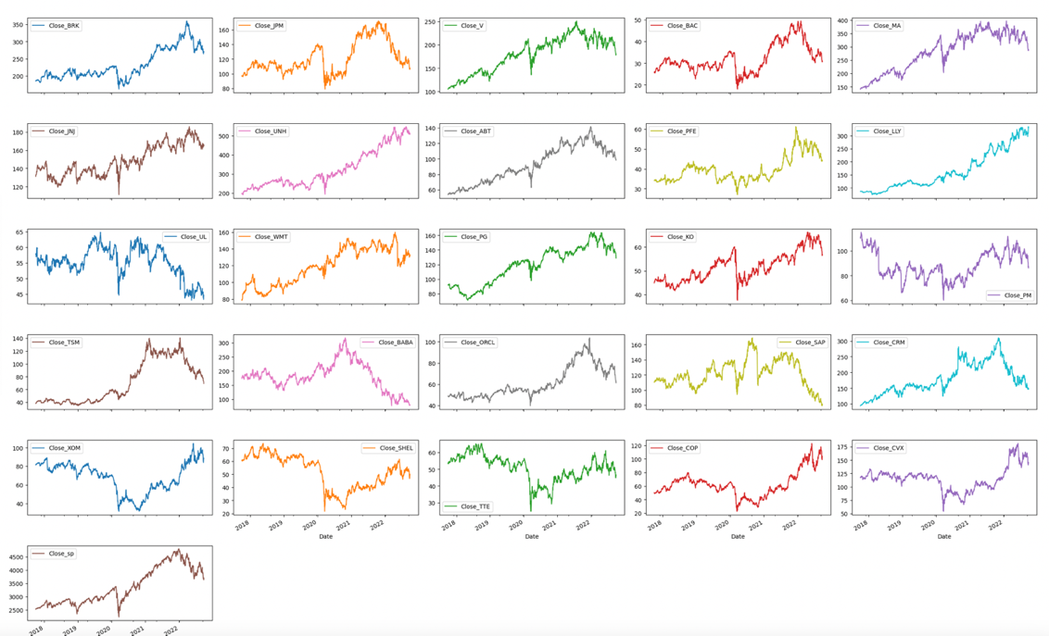

*Figure 4: Line Chart for Closing Price of Stocks*

In the time series graph for Closing prices, the stocks such as LLY, ABT, V, BAC, MA,UNH have an identical graph to S&P 500 Market Index which indicates they have seen an increase in their market closing prices over the period and could be a profitable choice while the ones with a decrease in same should be avoided for investment.

1. **Volume Analysis:** The volume analysis is important as it provides the information about the number of shares traded in a day. Higher volumes can be an indication of the higher market strength. The volume analysis was done through time series analysis by plotting the line graphs for the individual stocks and by plotting the histograms plots which would help to visualize the volume in terms of the volatility wherein higher is the standard deviation for the stock greater is the volatility and more will be the area covered by the stock in the graph.

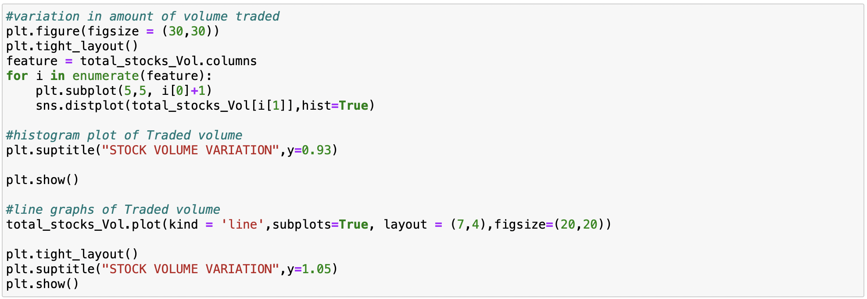

*Figure 5: Creating Traded Volume Graphs*

For the line graphs of the Stocks, ones with stable volume over the years has been mostly health stocks while a high variation of volume is seen for the financial stocks. The increase in volume is positive sign but for certainty we need to conduct more depth analysis.

**COMPARATIVE ANALYSIS:**

1. **Price Correlation Matrix:** After we have gained an overall understanding of the volatility and price variation across time we compared the performance of the price movement of the Stocks to the S&P 500 index price. The idea is to filter out the stocks which could be risky for investment and cannot be included in the portfolio.

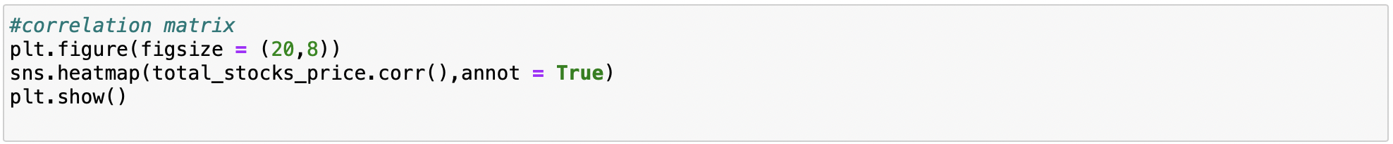

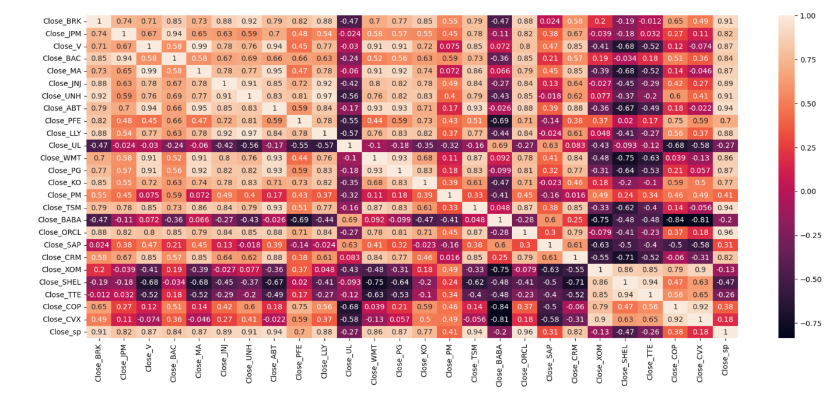

*Figure 6: Price Correlation Matrix of Stocks with Market Index*

According to the correlation matrix, the stocks with the highest positive correlation to market index are the ABT, ORCL, TSM, BRK AND UNH with the correlation coefficient 0.8 and above while the stocks like UL,BABA,XOM , SHEL and TTE are being filtered out as they have negative correlation with market index .

1. **Normalization:** Since the stock data for different stocks is in different scales so comparison of stocks will be done on normalized values to make it more convenient for comparing the data. The normalized values are then used to calculate the daily returns for the stock and visualizing the relative price variation with stock index prices. We have used normalized prices for plotting the increase of two stocks belonging to same category with the stock index to record the relative price variation.

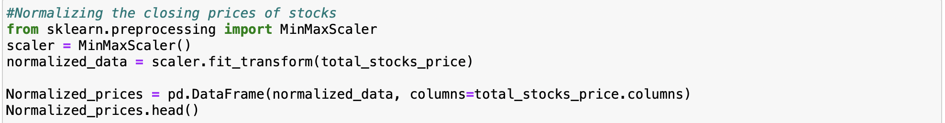

*Figure 7: Normalizing the Closing Prices*

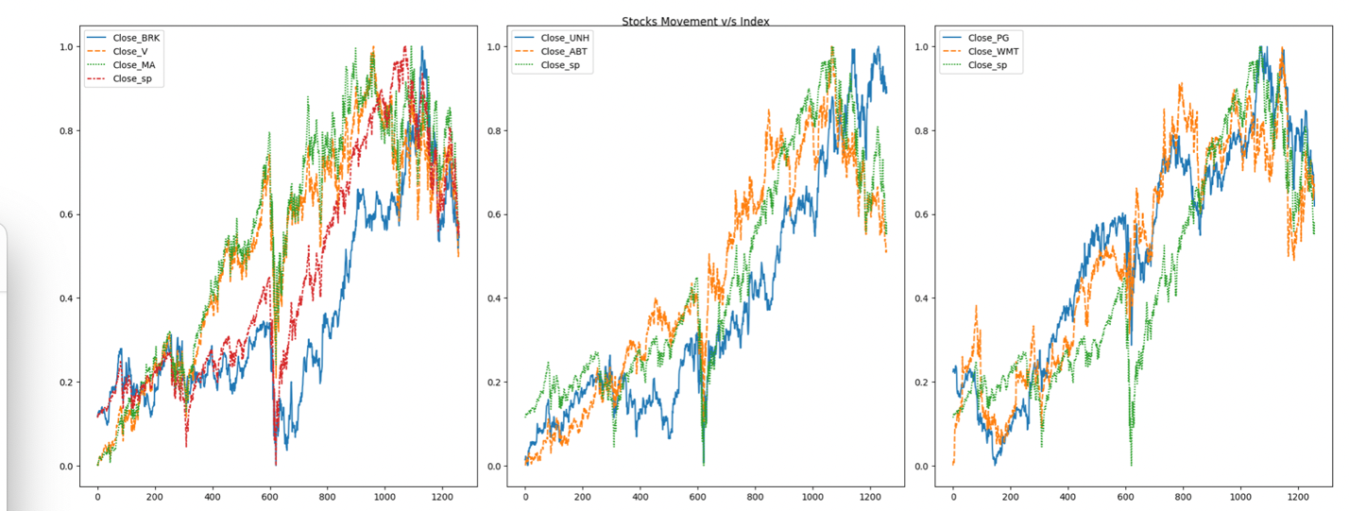

*Figure 8: Normalized Stock Price Movement Vs Market Index*

The plots indicate ABT, MA, V, PG and WMT outperforming the market index over time suggesting that these could be profitable investments for future with less risk.

1. **Daily Returns and Annualized Returns:** Return in any terms is simply a gain or loss for any investment. For stock analysis one of the most important factors for an active investment is the gain or loss of any investment in day.

Daily returns is calculated by comparing the closing price of one day with the closing price of the stock for previous day. The positive daily returns mean the stock price is appreciating on daily basis. For our data after we filtered out the stocks with negative correlation coefficient, we then used the remaining stocks for calculating the daily returns.

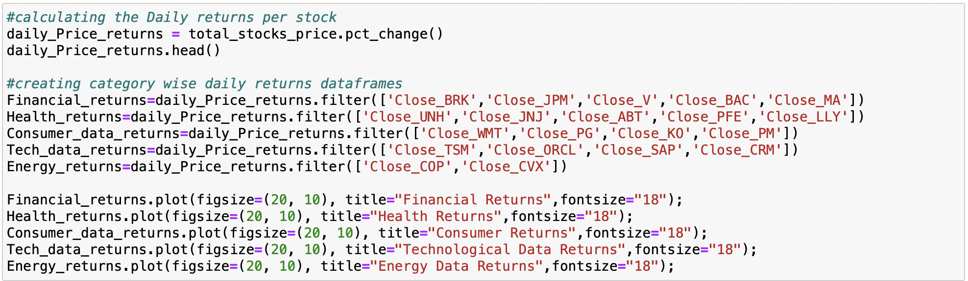

*Figure 9: Calculating Daily Returns*

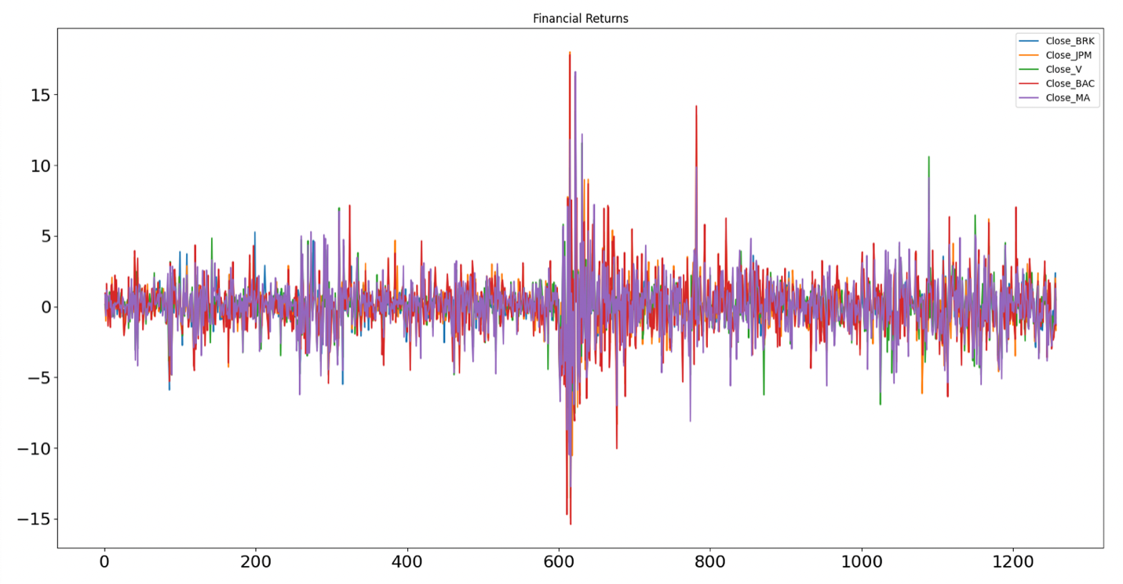

*Figure 10: Daily returns for Financial Category stocks*

The category wise returns line charts have been used to depict the daily returns for the stocks. For the daily returns charts the number of peaks is used to determine the volatility of daily prices. So, the stocks with most number of peaks irrespective of higher or lower peaks has seen the highest amount of change in their closing prices and hence more returns like the MA and BAC in the above figure while the one with least number of peaks like the V in the above figure is the one with less variation in daily prices and hence lesser chance of earning returns.

Annualized returns is the geometric mean of the money earned over an investment for a given period of time in case the annual return is compounded. We have simply taken the average of the daily returns and calculated the mean to determine the Annualized returns per stock in terms of percentage. The annualized returns of more than 10% is a good return for any investment. This helps to compare the investments done in time periods with one another.

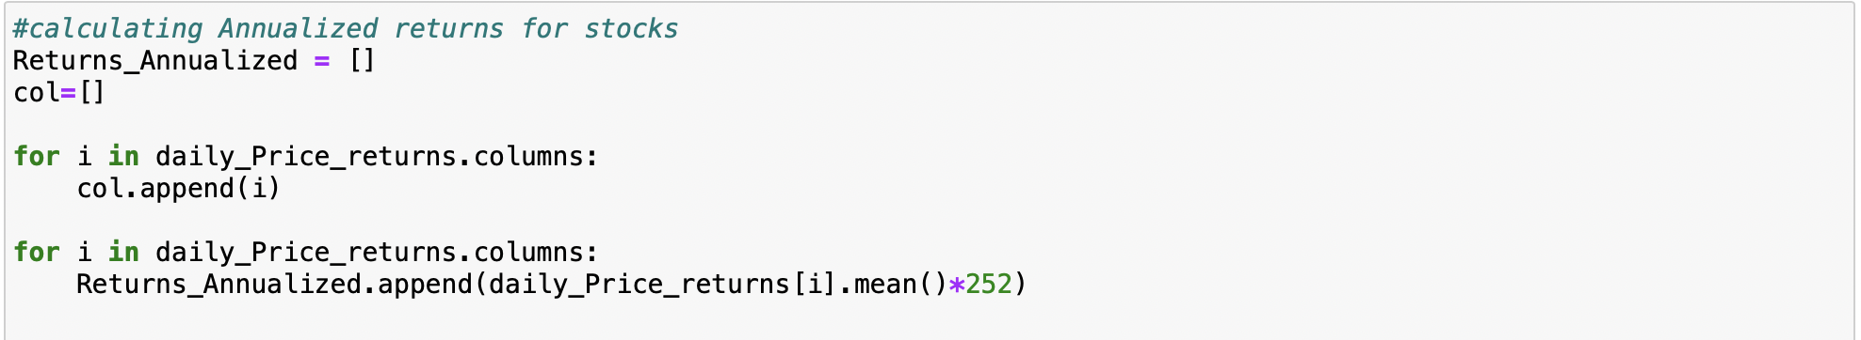

*Figure 11: Calculating Annualized Returns*

As per the calculations, the highest annualized returns have been calculated for LLY, UNH, COP and followed by MA and TSM. Similarly, the stocks with negative annualized returns over the year are SAP, BABA, UL and PM. The positive annualized returns over the year indicate the more profits can be earned for these stocks so these should be incorporated into the Portfolio.

**RISK ANALYSIS:**

1. **Annualized Risk:** Risk is amount of uncertainty associated with the performance of stock in stock market. Risk is directly linked to the volatility in the stock prices. The risk is simply calculated by taking the standard deviation of each stock and multiplying it with 252 trading days. Standard deviation helps determine market volatility or the spread of asset prices from their average price.

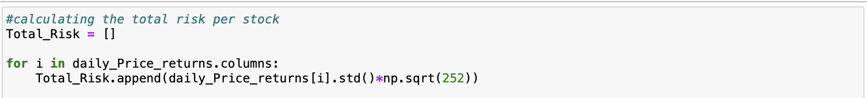

*Figure 12: Calculating Annualized Risk*

The risk calculated provides an idea of how far the expected returns can vary from the expected value. We have observed the following values of associated annualized returns and risk from the analysis.

1. **Sharpe Ratio:** The basic understanding of the sharpe ratio is the ratio of excess returns to the ratio of the risk associated with each investment. Sharpe ratio presents the balance of risk and return for an investor to make a choice for his portfolio. The stocks with sharpe ratio close to 1 are good choice since best performing stocks have sharpe ratio of 1 and above.



$$Sharpe Ratio=E[{R_{a}-R_{b}]}/{σ_{a}}$$

$$where;E=Expected return$$

$$R_{a}=Stock returns$$

$$R_{b}=Risk free rate of return$$

$$σ_{a}=Standard deviation of returns calculated$$

*Figure 13: Determination of Sharpe Ratio*



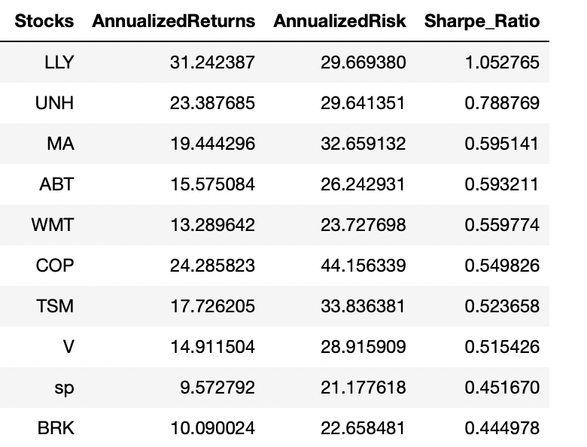

*Figure 14: Sorted Stock Values Chart W.r.t Sharpe Ratio*

The tabular representation of the Annualized returns, Annualized risk and Sharpe ratio provides us an understanding of how much risk is involved with each stock pertaining to the returns provided on the same. The ten stocks have been ordered as per the Sharpe ratio to decide the preferability for the stocks when creating the portfolio. The LLY with the Sharpe ratio of 1.05 is most desirable for the portfolio.

**PORTFOLIO CREATION:**

For application of the stock analysis we created a dummy portfolio for an aggressive investor who is ready to take risks and wants to focus on more returns wherein we selected top five stocks with highest Sharpe ratios namely LLY (40%), UNH (10%),MA(30%),ABT(10%) and WMT(10%). After creating a portfolio, we have calculated portfolio returns by calculating the Mean daily returns and Annualized portfolio returns.

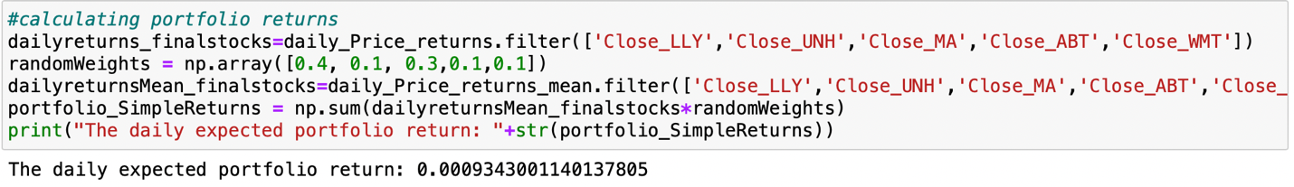

*Figure 15: Calculating Daily returns for Portfolio*

Overall, the Annualized returns for the created Portfolio have been calculated as the 23.54%. Based on calculated portfolio returns we have lastly created a chart to illustrate the returns gained by the investor in 2022 assuming he invested in the created portfolio in 2017.

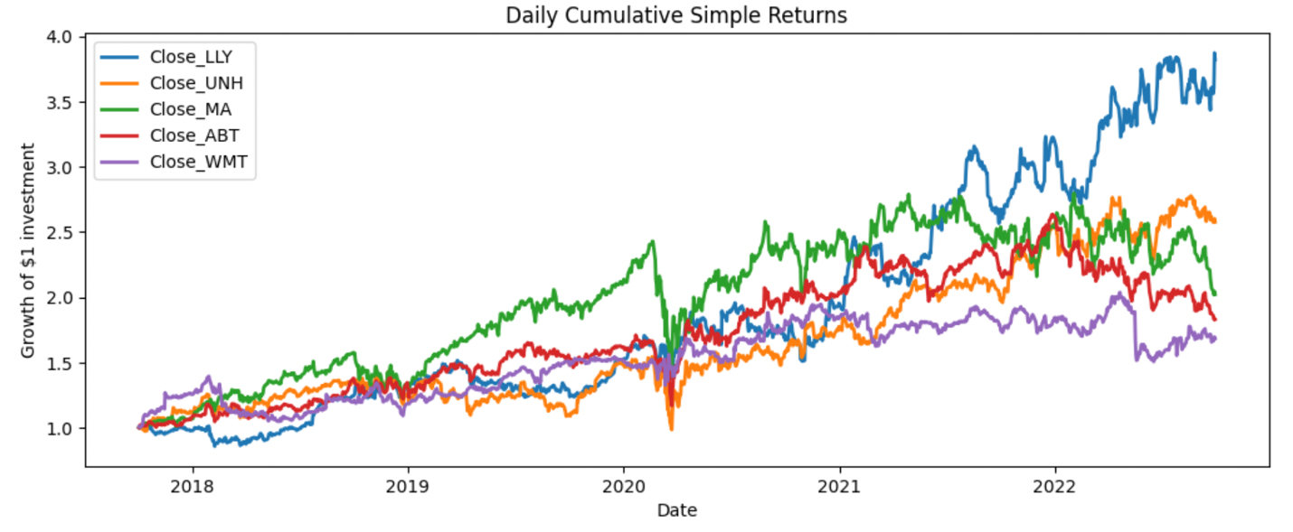

*Figure 16: Line Chart for Daily Portfolio Returns*

**CONCLUSION**: The project helps us to gain a better understanding of stock market, its fundamental calculations and an insight into returns and risk involved with investment. We can summarize our conclusion by following learnings:

* A profitable investment is very dynamic entity which is influenced by variety of factors and any highly priced stock may or may not be much profitable.
* Stocks performance is linked with the performance of the industry they belong to as we had health category stocks performing the best which could be a factor due to pandemic post 2020.
* Project also provided us a better understanding of Jupyter notebook and python language.